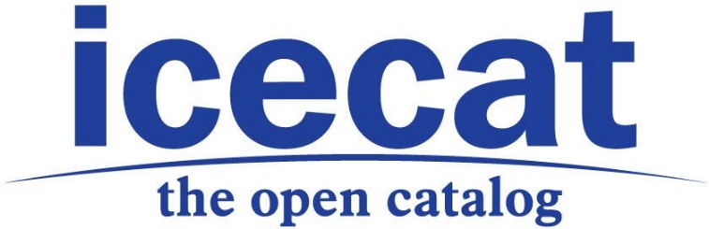

THIS ANNOUNCEMENT DOES NOT CONSTITUTE AN OFFER, OR THE SOLLICITATION OF AN OFFER, TO BUY OR SELL SECURITIES IN THE UNITED STATES OR IN ANY OTHER JURISDICTION.
PRESS RELEASE
Icecat Full Year 2016 Update
Amsterdam, The Netherlands, May 3, 2017: In 2016, Icecat’s revenues expanded by 10.3% to 6 million EUR, and the use of its product database by e-commerce companies grew by 29%.
2016 highlights:
- Icecat prepared its successful IPO at NPEX
- Icecat data-sheets downloads soured by 29% to 8.4 billion
- 64,736 supported channel partners, an expansion by 21%
- Revenues expanded by 10.3% to 6 million EUR
- Gross margin grew by 10.8% year-on-year
- Expansion to new sectors such as Toys, Do It Yourself and Fast Moving Consumer Goods.
During 2016, Icecat management has dedicated itself to the preparation and announcement of Icecat’s IPO at the Dutch SME Exchange NPEX.nl, which included among others reporting in IFRS, producing a prospectus for prospective investors, holding investor meetings to explain Icecat’s proposition, appointing a second board member, preparing the foundation of a STAK (Stichting Administratiekantoor) for the successfully realized listing of depositary receipts, and further professionalizing the internal organization.
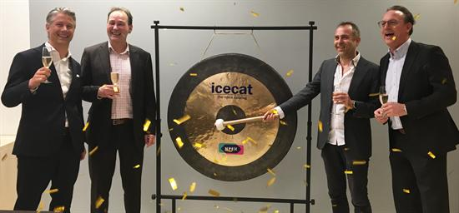
At the same time, Icecat focused during 2016 on continued fast-growth of its revenues, +10.3% compared to 2015, at an almost similar profit level, despite the consultancy costs related to the IPO preparation. The gross margin (gross profit) of the company increased by 10.8%, at a similar pace as its revenues. The EBITDA decreased by -22.3% to 766 thousand euro, because of IPO-related costs and attributing less editor costs as prepaid for 2017 (-230 thousand euro). There were no significant changes in number of staff and (ICT) investments during 2016, compared to one year earlier.
During 2016, Icecat was able to expand its business in Europe and globally (Rest of the World), and expanded its activities in the Toys, Health & Beauty, Do It Yourself and Fast Moving Consumer Goods sectors, as intended.

Non-financial KPIs: fast expansion of Icecat’s digital footprint
Regarding its non-financial KPIs (Key Performance Indicators), the number of data-sheet downloads expanded by 29% to 8.4 billion downloads, the number of supported manufacturer brands increased by 25% to 15 thousand, the number of supported product categories grew by 40%, and the estimated number of connected channel partners (ecommerce users) expanded by 21%. The number of technical platforms stagnated, due to the concentration of users on popular ecommerce systems, like Magento Commerce, PrestaShop, VirtueMart, Ebay and Amazon. (See also https://www.iceclog.com/magento-prestashop-and-virtuemart-among-most-popular-eshop-platforms-processing-product-data/ )
Some more detailed insights in the 2016 trends by category as measured by Icecat, can be found here: https://www.iceclog.com/do-it-yourself-beauty-toys-lighting-are-fastest-developing-e-commerce-verticals/
Some further insights in trends on manufacturer brand level as measured by Icecat, can be found here: https://www.iceclog.com/ecommerce-channel-top-10-2016-acer-doubles-its-footprint-diy-and-toys-soaring/
Innovation
The ICT innovation of Icecat has been focused during 2016 on improving its PIM-in-the-Cloud (Product Information Management service) for manufacturer clients like L’Oréal, the provisioning of product data through Icecat Live (a JavaScript and JSON based solution), it’s API-IN for manufacturers to automatically push its product data into the Icecat database, and piloting Artificial Intelligence in relation to optimizing editorial processes.
Financial KPIs
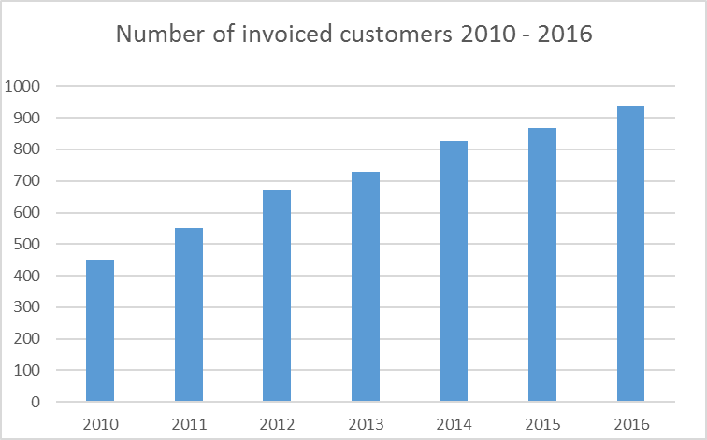
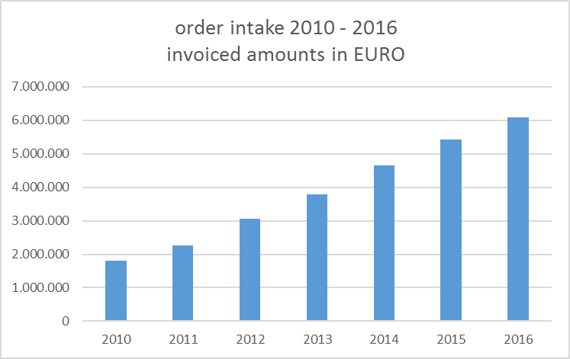
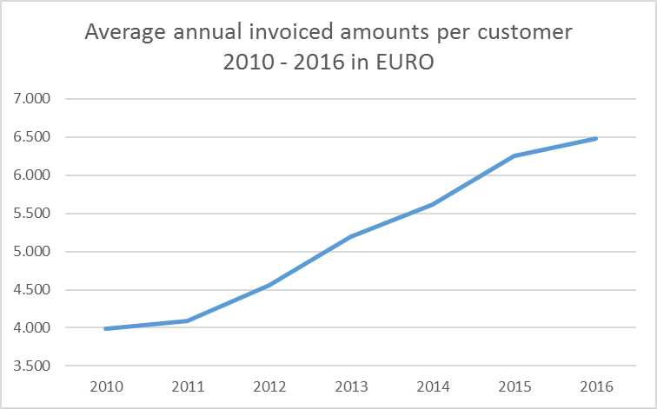

Balance sheet
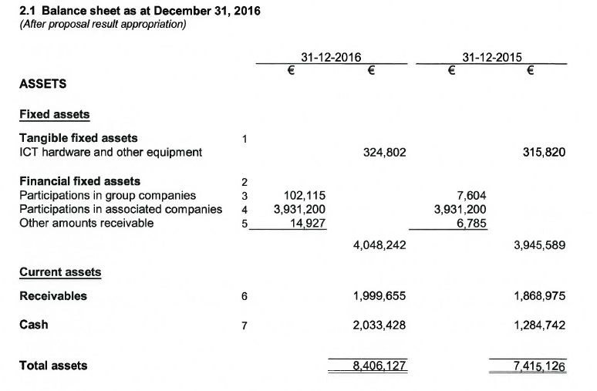
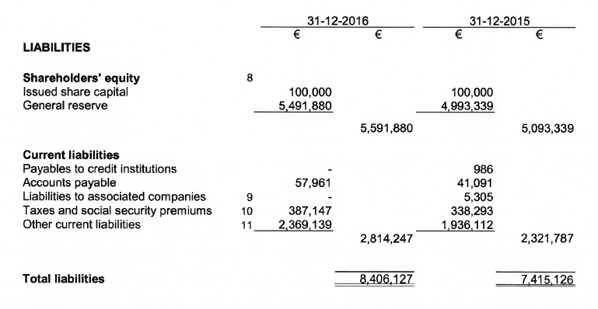
Incomes and expenses
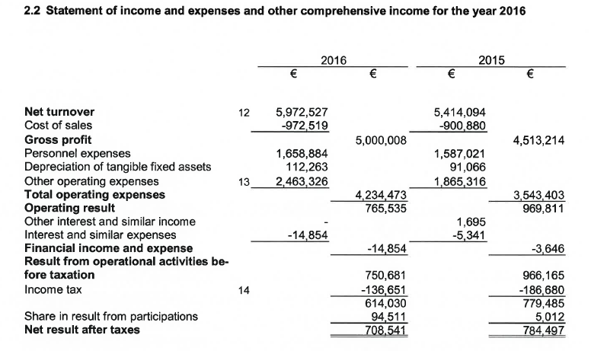
Cash flow
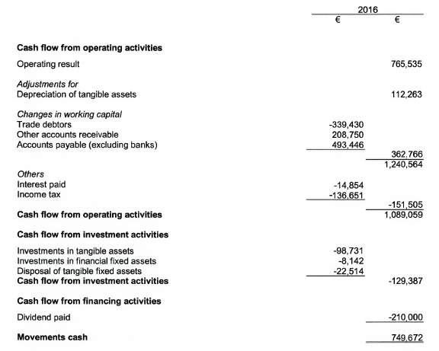
About Icecat NV
Icecat NV, which has recently announced its IPO, is a global publisher and syndicator of product information for the e-commerce market. Icecat NV, founded in 2009, works with some 65,000 webshops and hundreds of brands such as Philips, Sony, Samsung, HP, P&G, L’Oréal.
Icecat includes the subsidiaries Icecat LLC (Icecat Ukraine) and Icecat Content Sourcing OÜ (Icecat Estonia), and participation Hatch B.V. The cost centers Icecat Ukraine and Icecat Estonia are responsible for hiring editor and software developer capacity. Hatch BV (formerly Iceleads) delivers smart "Buy Now" buttons that help manufacturers to turn their websites into measurable lead generators for their online retailers. Icecat is finalizing its acquisition of Iceshop BV in May, an ecommerce software developer which is also part of the iMerge ecommerce group.

More information:
- Icecat NV: Martijn Hoogeveen, martijn.hoogeveen@icecat.com, +31654256476
- https://www.npex.nl/en/the-exchange/icecat/company-profile
- Annual Report 2016: https://www.iceclog.com/wp-content/uploads/2017/05/Jaarrekening-2016-Icecat-NV-inclusief-controleverklaring-was-signed.pdf

