NFON AG
introduces two-factor-
authentication
for hardware

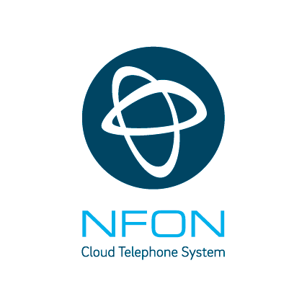

> Increased security for auto provisioning
> Commissioning only with entry of a Phone Authentication PIN (PAP)
> Press-Kit

Continuous evolution of the platform
NFON AG, the only pan-European cloud PBX provider, will introduce two-factor authentication (2FA) for end devices from January 30th, 2020. When commissioning new phones, the one-time entry of a so-called Phone Authentication PIN (PAP) will be necessary. "Security and reliability are of particular importance for NFON", says Jan-Peter Koopmann, Chief Technology Officer of NFON AG. "For this reason, we regularly carry out audits of our platform and work continuously on further improvements. Based on our analyses and the developments in the area of IT security, we have decided to further develop this mechanism in order to meet our high demands and to guarantee the highest possible security for our customers".

Security made in Germany
Up to now, hardware authentication on the platform has been done using methods such as device manufacturer’s certificate bound to the hardware and the MAC address of the device, if supported by the manufacturer. With the introduction of the 2FA, an end device connected to the NFON platform must be additionally and uniquely authorized with a six-digit code (PAP) in addition to the established authentication mechanisms. Such a procedure is also common in online banking and leads to an additional increase in security for all users. "We have designed this in such a way that mitigates the impact on the NFON auto-provisioning process that customers are used to" adds Jan-Peter Koopmann. "The authentication integrates itself with little effort into the familiar processes during setup. The rule of thumb is: When weighing convenience and security, security must be the main consideration". The new procedure only affects new devices that have not yet been registered with NFON. Clever functions especially for the commissioning of multiple devices make this procedure a real benefit for all customers and users.

Patent pending technology
NFON AG, as the provider of the communication structure, is not only an important but also safety-critical partner for all customers. Hans Szymanski, Chief Executive Officer and Chief Financial Officer of NFON AG: "That we are more than aware of this importance is demonstrated by this patent pending proprietary development, which is based on our consistent striving for improvement. And with this effort we will continue to be an innovator in the industry".

About NFON AG
Headquartered in Munich, NFON AG is the only pan-European cloud PBX provider – counting more than 30,000 companies across 15 European countries as customers. With Cloudya, NFON offers an easy-to-use, independent and reliable solution for advanced cloud business communications. Further premium and industry solutions complete the portfolio in the field of cloud communications. With our intuitive communications solutions, we enable European companies to improve their work a little, every single day. NFON is the new freedom in business communication. http://www.nfon.com/
Press-Kit
Hans Szymanski, Chief Executive Officer und Chief Financial Officer, NFON AG; Jan-Peter Koopmann, Chief Technology Officer, NFON AG
Contact for media
Please pick up your PR contact. Thank you.

Headquarter NFON AG  Thorsten Wehner  Vice President Public Relations  +49 89 45 300 121  thorsten.wehner@nfon.com |  | Deutschland  100zehn GmbH  Timm Caspari  +49 89 55 27 06 20  nfon@100zehn.de
United Kingdom  Jones Consulting (UK) Ltd  Claire Jones  +44 7826 528900  claire.jones@jonesconsulting.co.uk |  | España  LF Channel  Estela Cayón  +34 91 521 51 92  nfon@lfchannel.com
Österreich  PRofessional  Ulrich Taller  +43 1 524 97 07-0  nfon-pr@professional.at |  | Nederland  AxiCom  Mireille Sampimon  +31 20 754 698 1  mireille.sampimon@axicom.com
Italia  BPRESS  Mariateresa Faregna  +39 02 72 585 304  nfon@bpress.com |  | France  Yucatan  Elisa Lesieur + Emilie Debes  +331 53 63 27 21  nfon@yucatan.fr

Investor Relations
Sabina Prüser, Head of Investor Relations, +49 89 45 300 134, sabina.prueser@nfon.com

Disclaimer
This communication is for information purposes only and does not constitute an offer to sell or the solicitation of an offer to buy or subscribe for any securities of the Company. The securities discussed herein have not been and will not be registered under the U.S. Securities Act of 1933, as amended (the "U.S. Securities Act") and may not be offered or sold in the United States absent registration or an exemption from registration under the U.S. Securities Act. There will be no public offering of the securities discussed in this release in the United States of America and the information contained in this release does not constitute an offer of securities for sale. This announcement is not for distribution, publication or transmission, directly or indirectly, to or within the United States of America, Australia, Canada, Japan or any other jurisdiction in which such distribution is unlawful, or to U.S. persons.

