NFON supports over
160 psychotherapists
in telephone counselling
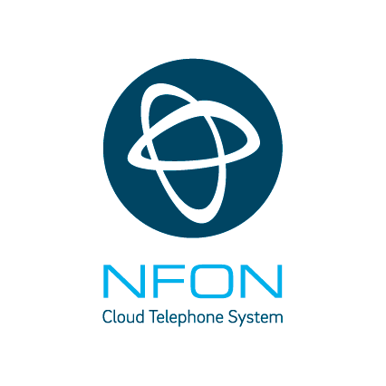
> Vienna Psychotherapy Helpline provides help in the crisis
> Over 160 psychotherapists conduct crisis talks via Cloudya
> Press-Kit

Simple and decentralized help
NFON AG, the only pan-European cloud PBX provider, works together with the Vienna Provincial Association for Psychotherapy (WLP = Wiener Landesverband für Psychotherapie) to offer personal assistance to people in the greater Vienna area despite profound restrictions in public life by using Cloudya, the telephone system from the cloud. Since the launch of the hotline (Psychotherapy Helpline), more than 750 people experiencing psychological strain could be supported during the corona crisis. The use of Cloudya at the WLP shows the advantages of cloud solutions: ready for use and scalable within 24 hours, easy to use and highly available. "We are really proud that we were able to support this outstanding project in Vienna, home of the three Viennese schools of psychotherapy, which go back to Sigmund Freud, Alfred Adler and Victor A. Frankl, by providing easy and quick access to the necessary tools for the home office, thus enabling mobile working even in these times. We are helping with cloud technology in this acute exceptional situation and point out that we will continue to do so in the probably even more important phase after the corona crisis", says Hans Szymanski, Chief Executive Officer and Chief Financial Officer of NFON AG.

Cloudya enables contact during the crisis
More than 160 psychotherapists are currently working for the Psychotherapy Helpline of the WLP and another 100 are on the waiting list. People can have calls with trained psychotherapists free of charge daily between 8:00 and 22:00 o'clock "to get professional counselling in stressful life situations during the Corona crisis, for example if people cannot deal with loneliness due to social isolation or if the family situation with home office and home schooling is overwhelming. But also when partnership disputes escalate or someone can’t stand boringness," says Leonore Lerch, chairwoman of the WLP. "Immediate telephone counseling is necessary to prevent chronic stress and psychological strain. The situation is shaking the foundation of many people’s sense of security. We will be studying the impact of the crisis on mental health for a long time." The psychotherapists work with the Cloudya telephone system, independent of device and location, and can have conversations via the browser with their Mac or PC or via the Cloudya app by using a smartphone (iOS and Android). The originally existing number of extensions, which were already in use by the WLP before the Covid-19 pandemic, has been quintupled for the Psychotherapy Helpline!

Milestone of digitization
Hans Szymanski: "This lighthouse project is a blueprint for companies far beyond Austria's borders. In retrospect, 2020 will be remembered as a milestone in digitization. We can all make a contribution to Europe’s future; cloud technologies have finally been established and are undoubtedly becoming indispensable.”

About NFON AG
Headquartered in Munich, NFON AG is the only pan-European cloud PBX provider – counting more than 40,000 companies across 15 European countries as customers. With Cloudya, NFON offers an easy-to-use, independent and reliable solution for advanced cloud business communications. Further premium and industry solutions complete the portfolio in the field of cloud communications. With our intuitive communications solutions, we enable European companies to improve their work a little, every single day. NFON is the new freedom in business communication. http://www.nfon.com/
Press-Kit
Hans Szymanski, Chief Executive Officer und Chief Financial Officer, NFON AG; Leonore Lerch, Vorsitzende des Wiener Landesverbandes für Psychotherapie
Contact for media
Please pick up your PR contact. Thank you.

Headquarter NFON AG  Thorsten Wehner  Vice President Public Relations  +49 89 45 300 121  thorsten.wehner@nfon.com |  | Deutschland  100zehn GmbH  Timm Caspari  +49 89 55 27 06 20  nfon@100zehn.de
United Kingdom  Jones Consulting (UK) Ltd  Claire Jones  +44 7826 528900  claire.jones@jonesconsulting.co.uk |  | España  LF Channel  Estela Cayón + Eloína Rivero  +34 91 521 51 92  nfon@lfchannel.com
Österreich  PRofessional  Ulrich Taller  +43 1 524 97 07-0  nfon-pr@professional.at |  | Nederland  Axicom  Mireille Sampimon  +31 20 754 698 1  mireille.sampimon@axicom.com
Italia  BPRESS  Mariateresa Faregna  +39 02 72 585 304  nfon@bpress.com |  | France  Yucatan  Elisa Lesieur + Emilie Debes  +331 53 63 27 21  nfon@yucatan.fr

Investor Relations
Sabina Prüser, Head of Investor Relations, +49 89 45 300 134, sabina.prueser@nfon.com

Disclaimer
This communication is for information purposes only and does not constitute an offer to sell or the solicitation of an offer to buy or subscribe for any securities of the Company. The securities discussed herein have not been and will not be registered under the U.S. Securities Act of 1933, as amended (the "U.S. Securities Act") and may not be offered or sold in the United States absent registration or an exemption from registration under the U.S. Securities Act. There will be no public offering of the securities discussed in this release in the United States of America and the information contained in this release does not constitute an offer of securities for sale. This announcement is not for distribution, publication or transmission, directly or indirectly, to or within the United States of America, Australia, Canada, Japan or any other jurisdiction in which such distribution is unlawful, or to U.S. persons.

