Zyxel Networks’ new high-performance firewall keeps businesses fast and secure
The new USG FLEX H series delivers triple performance to keep SMBs secure while working at multi-gigabit speeds
October 23, 2023—Zyxel Networks, a leader in delivering secure, AI-powered cloud networking solutions, has announced the launch of its USG FLEX H series of secure firewalls – a new line of appliances designed to provide small and medium-sized businesses (SMBs) with exceptional multi-gigabit performance and advanced security.
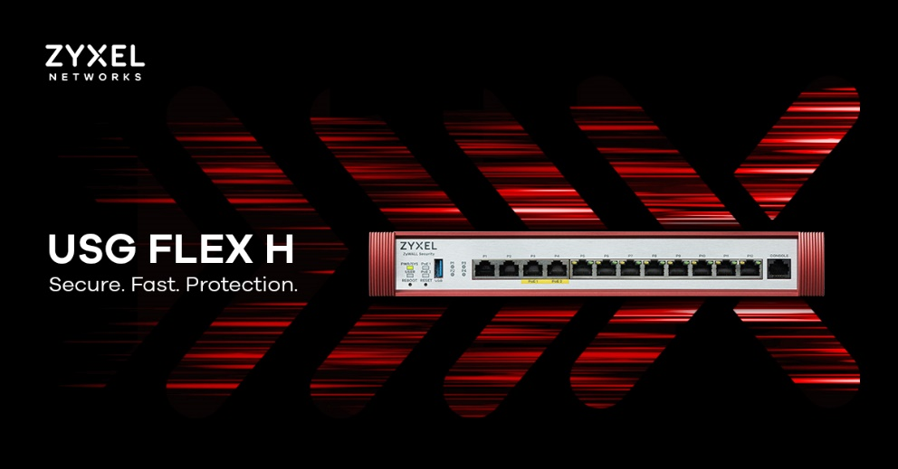
High-speed triple performance
As businesses continue to upgrade their connected devices and networks to multi-gigabit levels, they require a firewall that delivers the same speed and performance. The USG FLEX H series provides a triple performance firewall, VPN, and Unified Threat Management (UTM) throughputs, along with multi-gigabit speed ranging from 1G and 2.5G to 10G, offering SMBs ample capacity to accommodate their growing network demands.
Select models come with Power over Ethernet (PoE) options, featuring a power budget of up to 30W, to enable seamless connectivity and powering of devices such as 5G routers (FWA710) and WiFi 6E Access Points (APs), simplifying network cabling. The inclusion of software-defined Ethernet ports, previously only found in enterprise-grade products, provides the flexibility to meet your requirements (selectable LAN/WAN), offering greater versatility in network setups.
Ken Tsai, Senior Associate Vice President of Zyxel Networks’ Gateway SBU, said: "The USG FLEX H series offers SMBs unparalleled performance, enhanced security, and a simplified user experience. This new generation of high-performance Zyxel Networks firewall appliances gives them the speed and capabilities they need to adapt to the evolving security demands of multi-gigabit networks and provide effective protection for their valuable digital assets."
AI-powered security and hassle-free management
To counter the increasingly complex threats targeted at businesses, the USG FLEX H series leverages AI-powered cloud intelligence to deliver multi-layered protection. The defense system includes sandboxing, anti-malware, DNS/IP/URL filtering, intrusion prevention system (IPS), and application patrol. Additionally, the firewalls support widely used VPN protocols, such as IKEv2/EAP and SSL VPN, across multiple OS platforms, all covered by a single Zyxel Networks SecuExtender VPN Client license key.
Helping to simplify tasks for network admins, the USG FLEX H series provides both standalone and centrally managed protection through Zyxel Networks’ Nebula Cloud. Admins can swiftly onboard devices using the Nebula app and seamlessly switch between the device GUI or Nebula Control Center to manage the network. This ensures secure connections and enables centralized management of wired and wireless devices, as well as security devices, all from a single pane of glass.
Enhanced user experience with uOS
Built with a focus on user experience, the USG FLEX H series comes equipped with a new operating system, uOS. The system offers a simple, modern, and intuitive interface, enhances the overall usability, and accelerates the system’s response when processing complex configurations. Additionally, its graphical dashboard offers a clear and comprehensive overview of the entire network's security landscape, helping network admins to make quick and informed decisions for timely threat response.
The USG FLEX H series includes six models to meet the versatile requirements of SMBs. The bundled version includes a one-year Gold Security Pack license, which covers services such as sandboxing, reputation filter, Nebula Pro Pack, SecuReporter, and more.
All models will be available from Zyxel Networks partners from late October 2023. For more information about the USG FLEX H series, please visit: https://www.zyxel.com/USGFLEX-500H

About Zyxel Networks
Zyxel Networks is a leading provider of secure, AI-powered cloud networking solutions for SMBs and the enterprise-edge. We deliver seamless connectivity and flexible scalability through subscription services, all backed by robust security. With a reputation built on decades of unlocking potential and helping people adapt to the changing workplace, Zyxel Networks has earned the trust of over 1 million businesses across 150 markets.
Media Contact
Karen Spencer
Zyxel Networks
karen.spencer@zyxel.eu
+44 (0)118 936 4229

Based on a comparison with the previous generation of Zyxel security appliances.
Supported features will be expanded through rolling updates.

