Release of Remain Software Milestone Enhancements Boost Efficiency and Productivity for Organizations on IBM i and Multi-platform
FOR IMMEDIATE RELEASE CONTACT: María G-Juanes, Marketing
Assistant, NL
February 26, 2020 +31 30 600 50 10; maria.garcia.juanes@remainsoftware.com

NIEUWEGEIN, Netherlands — Remain Software delivered today its latest “Milestone” releases for the company’s three signature change-management, workflow and API editing and management tools: TD/OMS, Gravity and OpenAPI Studio.
In line with the company’s longstanding commitment to ongoing product and customer support, today’s Milestones mark the second of three scheduled enhancements to the current versions. These releases further Remain’s support for third-party tools and feature notable enhancements to integrations, user interfaces, source-management and more, marking expansions in clarity, productivity and control as users navigate business project-management and end-to-end software and application development, Wim Jongman, CTO and co-managing partner, explained. Annual full-version releases occur every summer.
TD/OMS V12 Milestone 2 incorporates an array of intuitive, efficiency-boosting refinements built to further streamline and enhance customers’ software application change- and lifecycle-management. They include: increased usability with our Git interfaces, including full Bitbucket support; extended capabilities for Remain’s Xref advanced cross-reference and impact-analysis for IBM i and multi-platform; and the ability to add labels to objects for speed and efficiency in filtering, finding and organizing them. (See page 3 for more information.)
Gravity V5 Milestone 2 features enhancements to increase the user-friendliness and expand the advantages of overall implementation of this robust business-collaboration and project-workflow-management increasing productivity across all teams. They include: giving customers more control over user-interface configuration, setting maximum attachment size limits, and for sources not located in a repository an Xref location can now be provisioned using file-transfer mechanisms. (See page 4 for more information.)
While TD/OMS and Gravity deliver outstanding results when used independently, customers often combine the two in order to compound and optimize their capabilities for ultimate productivity and total, end-to-end application-lifecycle management, including change-management, DevOps and workflow, Laura Hamway, managing director of Remain Software Inc., said. Both Milestones aim to boost productivity and efficiency for software professionals through their development, testing, integration and delivery cycles.
OpenAPI studio V1.0.10: This new-version release makes Remain’s OpenAPI Studio and editor more functional, easy to use and applicable to the jobs that matter to customers. New features include the ability to easily convert Swagger APIs to OAS3 and a local server through which users can tunnel to avoid CORS restrictions while testing APIs on the Web. (See page 5 for more information.)
Engineered for both IBM i and multi-platform architecture, all three solutions are in-house developed. This enables Remain’s development team to update its code for rapid and future-ready adaptation and integration for/with new and emerging technologies and release new features and capabilities to customers four times a year.
“We are pleased with the rhythm we provide with the quarterly Milestones,” Jongman said. “The timing and predictability built into our scheduling honor both: A) our customers’ feedback and anticipation of our prompt attention to it, and B) our development team’s ability to plan and engineer accordingly with neither haste nor delay. Customers never wait long for upgrades or fixes, as the next Milestone or new version release is always less than three months away”.
“Our customers really look forward to the quarterly releases,” Jongman continued. “This drives us to think daily about what value we can add and where. For example,” he noted, “this Milestone is dedicated to the new tagging functions and improvements in the Git usability. Our goal is that every Milestone includes something for everyone.”

For a quick preview, please see a few highlights with images below. For more information, visit the Milestones’ landing pages at:
TD/OMS Milestone: https://remainsoftware.com/news/tdoms-v12-milestone-2-enhances-support-change-management-integration-and-total-alm
Gravity Milestone: https://remainsoftware.com/news/gravity-v5-milestone-2-increases-efficiency-productivity-and-progress-devops-and-workflow
OpenAPI Milestone: https://remainsoftware.com/news/designing-rest-api-openapi-studio

With offices in Virginia, U.S.A. and Nieuwegein, Netherlands-based Remain Software specializes in robust, reliable, flexible IT solutions for change- and application-lifecycle-management, workflow, DevOps and integration, and more. Three Milestone releases follow each annual version release of TD/OMS, Gravity and OpenAPI Studio, Remain’s primary, in-house-developed tools. Visit www.remainsoftware.com

###

TD/OMS Milestone 2 highlights:
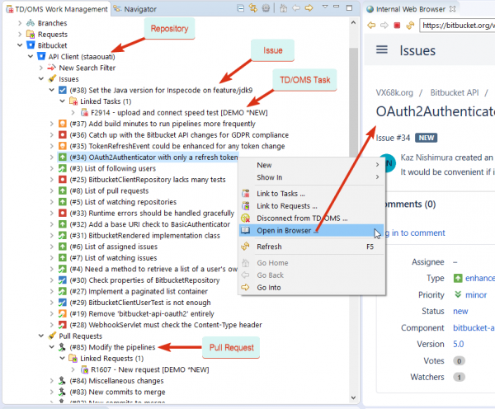
Bitbucket support
Our latest version has full support for Bitbucket, including:
- Uploading IBM i and/or IFS sources.
- Workflow integrations.
- Ticket integration.
- Merge request integration.

Labels
We have enabled the ability to add labels to objects. Users can now trigger actions, compiles and location selections and filter them in the "Components View" of the GUI. Labeling allows users to work with groups of objects faster and more easily. Labels can be created in the GUI or in green screen with a command-line API and then managed as needed.
How simple is it to label an object?
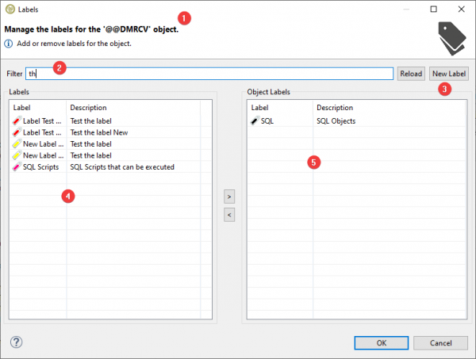
Right-click on the object in the task or components views and select “Labels...”
The label dialog will appear, enabling you to label an individual object.
Easily navigate through:
- Adding/creating a new label.
- Filtering capabilities.
- Labeling an object.
- Retrieve a list of available labels (filtered items).
- Obtain a list of all the labels associated with an object.
Organize objects more efficiently, and make life easier!
Additional Git enhancements for a seamless experience
- Add Git menu to "Show in" menu.
- Add Git to the “Definitions” view.
- Directly link created pull request to the TD/OMS task.
- Allow double-clicking interaction on task objects in the Git view.
- Show a warning when file is not committed to Git.
Gravity V5 Milestone 2 highlights:

Attachment size limit
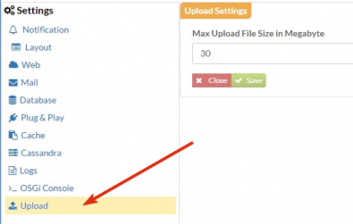

Now it is possible to configure the maximum file upload size, enabling more consistency and control for those who need it.

Xref with FTP, SFTP, SMB

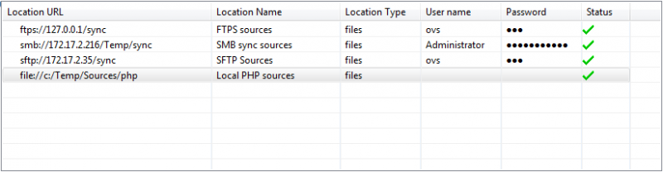
If your sources are not located in a repository then an Xref location can now be provisioned using file transfer mechanisms such as SFTP and SMB (Windows share). The location type “Files” will accommodate the file transfer protocol FTP, FTPS, SFTP, SMB and local file copy.

Xref with sources on an IBM i IASP

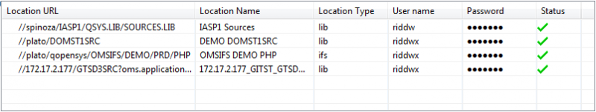
For source libraries that are located on the IBM i and stored on an independent auxiliary storage pool (IASP), Xref can access these libraries by providing the fully qualified location of a source library.

OpenAPI V1.0.10 highlights:
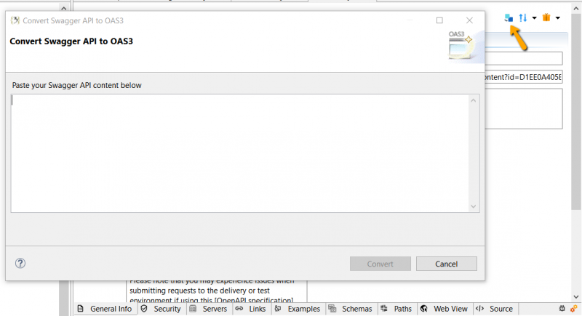
Convert Swagger APIs to OAS3
Now you can directly and easily convert Swagger-2 APIs to support OAS3-compliant specifications within our OpenAPI Studio, saving you time otherwise spent on unnecessary pre-studio conversion steps.

Circumvent CORS restrictions
Bypass the chaos while testing APIs via the Web. Now users can effectively avoid cross-origin resource sharing (CORS) restrictions by tunneling requests through a local server. Fetch APIs, deploy fonts and more without the standard cross-site-request frustrations.
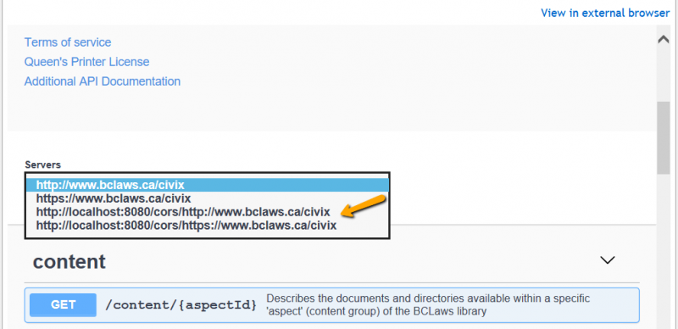

Press release TDOMS V12, GRAVITY V5 Milestone 2 and OpenAPI Studio V1.0.10 Remain Software BV

